PATIENT INFORMATION EMAIL ADDRESS:
First Name: | Last Name: |  |  |  |  |  |  | Middle Initial: |  |  |  |  |  |  |  | Date: / /
Address: |  |  |  |  |  |  | City: |  |  |  |  |  |  | State: |  |  |  | Zip:
Birth date: / / | Age: |  |  |  |  | Male Female |  |  |  |  |  |  | S.S. #: - -
Home Phone: ( ) - |  | Alternative Phone (Cell, Pager): ( ) - |  |  |  |  |  |  |  |  |  |  |  |  |  |  | Spouse:
Chose Clinic Because/ Referred to Clinic By Dr.: Insurance Plan Family Friend
Former Patient Close to Work/Home Website Yellow Pages Street Sign Other:
WORK INFORMATION
Employer: |  |  |  |  |  |  |  | Work Phone ( ) - |  |  |  |  |  |  |  |  |  |  |  | Ext.
Occupation: |  |  | Employment Status Full Time Part Time Retired Not Employed
CARE PROVIDER INFORMATION
Referring Dr: |  |  |  |  |  |  |  | Referring Dr. Phone: ( ) -
Regular Dr./PCP |  |  |  |  |  |  |  | Regular Dr./PCP Phone: ( ) -
INSURANCE INFORMATION (PLEASE GIVE YOUR INSURANCE CARD TO THE RECEPTIONIST )
Primary Insurance Name:
Subscriber’s Name (If different): |  |  |  |  |  |  |  |  |  |  |  |  |  |  | Birth date : / /
ID. #: |  |  | Group/Policy #
Patient’s Relationship to Subscriber: Self Spouse Child Other:
Name of Secondary Insurance:
Subscriber’s Name: |  |  |  |  |  |  |  |  |  |  |  |  |  |  | Birth date : / /
ID. #: |  |  | Group/Policy #
Patient’s Relationship to Subscriber: Self Spouse Child Other:
AUTO OR WORK INJURY CLAIM (PLEASE PROVIDE YOUR INSURANCE INFORMATION FOR BACKUP )
Insurance Name: Auto : Labor & Industries:
Adjuster/Claim Manager: |  |  |  |  |  |  |  |  | Phone: |  |  |  |  |  |  |  |  |  |  | Ext.:
Address: |  |  |  |  | City |  |  |  |  |  | State: |  |  |  |  |  |  |  | Zip:
Claim #: |  | Accident Date: / / |  |  |  |  |  |  |  | Cause:
ATTORNEY INFORMATION
Name: |  |  |  | Law Firm: |  |  |  |  |  |  |  | Phone: ( ) -
Address |  |  |  |  | City |  |  |  |  |  | State: |  |  |  |  |  |  |  | Zip:
IN CASE OF EMERGENCY
Name of Local Friend or Relative (Not Living at Same Address):
Relationship to Patient: |  | Home Phone: ( ) - |  |  |  |  |  |  |  | Work Phone: ( ) -
I authorize my insurance benefits be paid directly to Empower Physical Therapy & Aquatics Institute. I understand that I am financially responsible for any balance. I also authorize Empower Physical Therapy & Aquatics Institute to release any information required to process my claims. My typewritten name below signifies my authorization.

PATIENT /GUARDIAN SIGNATURE DATE

PAST MEDICAL HISTORY FORM Patient Name _
BLOOD PRESSURE | YES | NO |  | JOINT CONDITIONS YES NO
Hypertension  Low Blood Pressure Normal Blood Pressure |  |  |  | Upper Extremity Dislocation  Lower Extremity Dislocation
HEART DISEASE | YES | NO |  | OTHER CONDITIONS YES NO
Heart Attack Atherosclerotic Disease Myocardial Infarction Rheumatic Heart Disease Heart Murmur  Do you have a pacemaker |  |  |  | Muscular Dystrophy Rheumatoid Arthritis Multiple Sclerosis Epilepsy  Gout Fibromyalgia
MUSCLE CONDITION | YES | NO | Diabetes
Carpal Tunnel R/L Tennis Elbow R/L Back/Neck Problems Limited Limb Movement |  |  |  | Hearing Loss Poor Eyesight Fainting Polio  Other:
LUNGS YES NO
Asthma Emphysema

Shortness of Breath

EXERCISE |  | WORK ACTIVITY |  | STRESS LEVEL |  | HABITS
None Sitting Low Smoking Packs a Day 1-2 x Week Standing Medium Alcohol Drinks a Week 3-4 x Week Light Labor High Coffee/Soda Cups a Week 5+ x Week Heavy Labor

What types of exercise do you perform? : What things cause stress in your life? :

Are you taking any seizure medication? YES NO If yes list name: Are you taking any medications that might affect your lungs, heart, consciousness or general well-being while participating in therapy?
YES NO If yes list name:

List all medications you are currently taking:
List all surgeries in the past two years (Including dates):
Are you What
pregnant? YES NO week?:

Have you had any injuries related to work? YES NO If yes list body part and date.:
Have you had any Auto Accidents | YES | NO | If yes list body part and date.:
Have you had Physical Therapy or Massage Therapy before? YES NO Where:

Signature of Patient, Parent, Guardian, Personal Representative Date

Pain and Symptom Status Report
Name Date

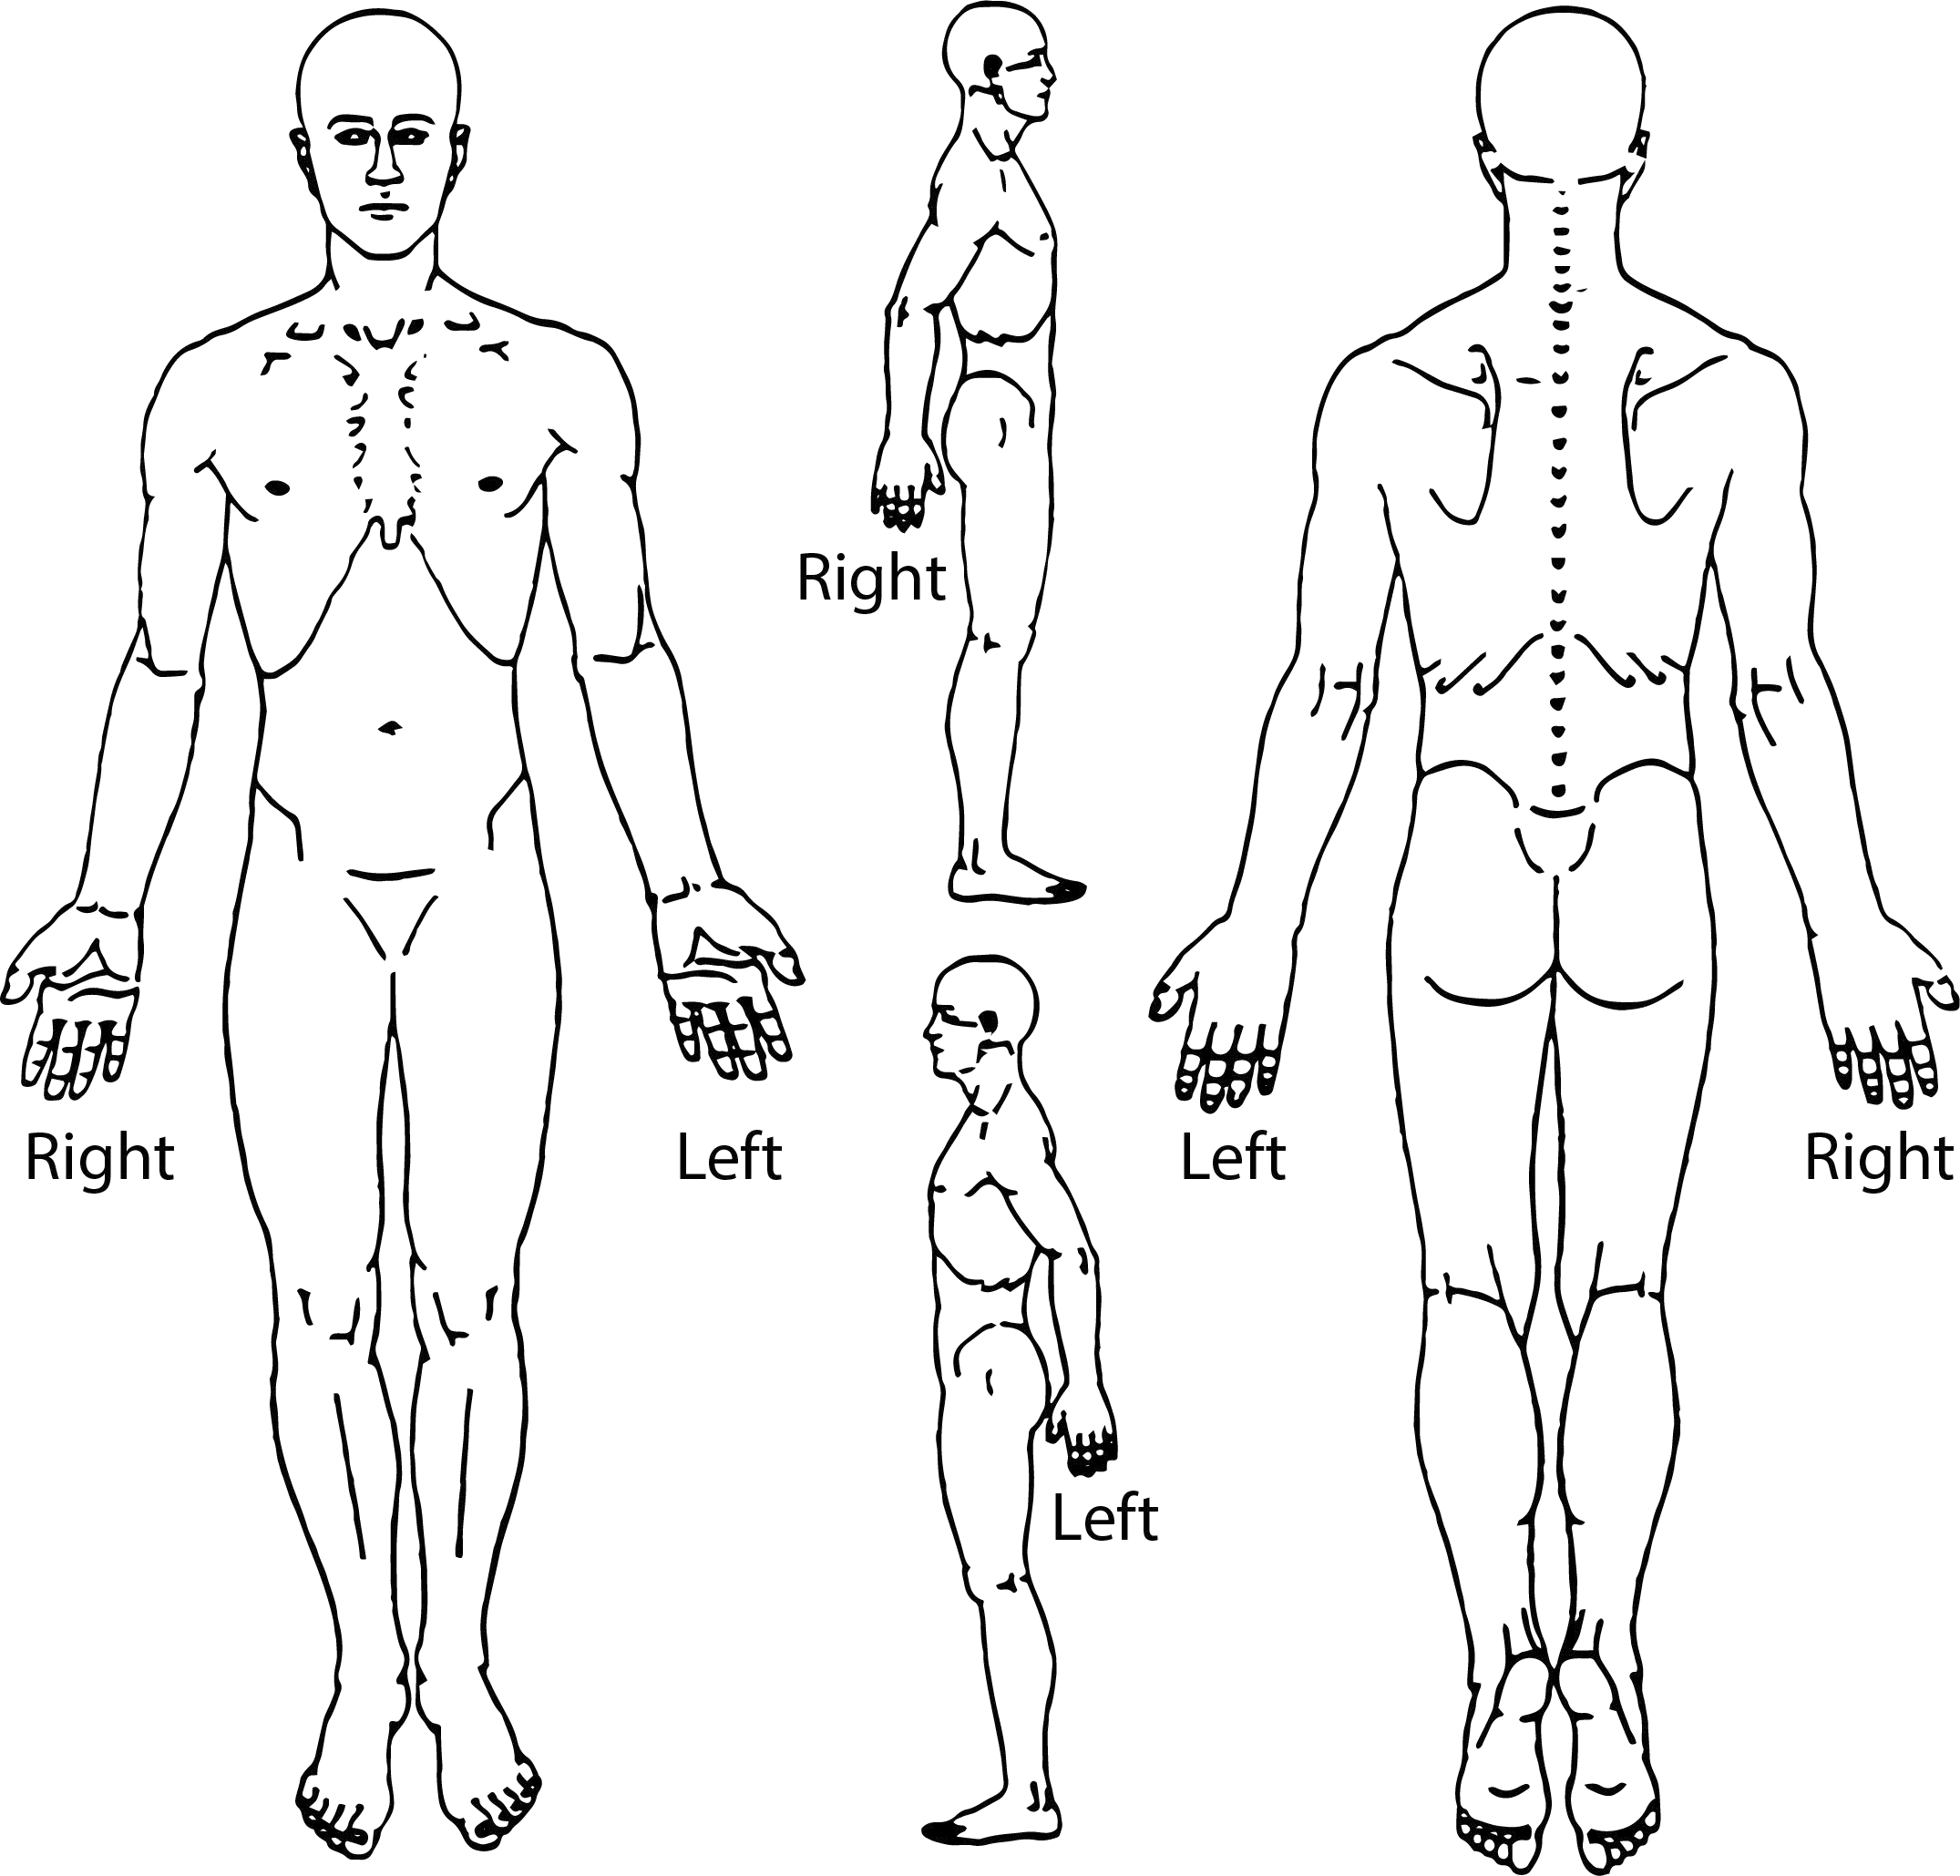
Using the symbols below, please draw at the location on the body outlines, the type of pain you are experiencing.

Ache | Burning | Numbness
MMMM | – – – | ¢¢¢¢
MM | – – | ¢¢¢
Pins & Needles | Stabbing | Other
☐☐☐☐☐☐☐☐ | / / / / / / / / | x x x x
☐☐☐☐☐☐ | / / / / / | x x x

Chief Complaint and Visual Analog Scale
My Chief Complaint is:

Date First Symptom of Your Problem Occurred on:

2nd Complaint:

3rd Complaint:

No Pain | 0 | Please circle on the scale below to indicate your CURRENT level of pain:  1 2 3 4 5 6 7 8 9 10 Pain as bad as it gets
No Pain | 0 | Please circle on the scale below to indicate your AVERAGE level of pain:  1 2 3 4 5 6 7 8 9 10 Pain as bad as it gets
No Pain | 0 | Please circle on the scale below to indicate your WORST level of pain:  1 2 3 4 5 6 7 8 9 10 Pain as bad as it gets

Additional Comments:

777 Corporate Dr Ste 160 Ladera Ranch, CA 92694
(949) 545-7007

CONSENT TO USE AND DISCLOSE PROTECTED HEALTH INFORMATION

Your protected health information will be used by this practice, known as Empower Physical Therapy & Aquatics Institute or disclosed to others for the purpose of treatment, obtaining payment or supporting the day-to-day health care operations of the practice.

We are providing you with a copy of our Notice of Privacy Practices. We request that you review the notice prior to signing this consent. You may request a restriction on the use or disclosure of your protected health information. If you wish to restrict your disclosure, you should make that request in writing.

This practice, however, may or may not agree to restrict the disclosure of your protected health information.

If we agree to your request, the restrictions will be binding. Use or disclosure of protected information in violation of an agreed upon restriction will be a violation of federal privacy standards.

You may revoke the consent to the use and disclosure of your protected health information. You must revoke this consent in writing. Any use or disclosure that has already occurred prior to the date of your revocation of consent is received will not be affected.

This practice reserves the right to modify the privacy practices outlined in the notice.

SIGNATURE

I have reviewed this consent form and have reviewed the Notice of Privacy Practices. By typing my name on the signature line below, I give my permission to this practice to use and disclose my health information in accordance with it.

Name of Patient (Print Clearly)

Signature of Patient Date

Signature of Patient Representative

Relationship of Patient Representative to Patient

PAYMENT AUTHORIZATION

Assignment of Insurance Benefits
Initials
I authorize that the payment of my insurance benefits be made directly to Empower Physical Therapy & Aquatic Institute, hereafter referred to as "FACILITY", for any services that are reimbursable by Medicare, Medicaid or any third-party payors.

Guarantee of Payment
I understand that all payments designated as “the patient’s responsibility” are due and payable at the time of service or billing. I guarantee that I will pay:
My designated portion including co-pays/co-insurance and my deductible
Initials

All amounts due for services that my insurance company has stated are
Initials not covered benefits (IF I have been advised by FACILITY in advance of the service delivery and have authorized it in writing)

All amounts due for services billed by FACILITY but paid directly to me
Initials

All amounts due for services billed by FACILITY to a Workers’ Compensation
Initials payor which was subsequently declared by my employer to be a non-eligible claim
All amounts due for claims submitted by FACILITY to my insurance company
Initials and not paid by 60 days

Medicare and Workers’ Compensation Information

I certify that the information I have provided to FACILITY for payment under
Initials the Social Security Act (Medicare) or under the Workers’ Compensation Program is correct, including but not limited to any related accidents/illness or other insurers/payors available.

By typing my name below, I, , understand the statements I have authorized above and declare their truthfulness.

Patient or Authorized Representative for Patient Signature/Date Initials

Informed Consent for Therapy Services

“Informed Consent” is a process for getting permission before we provide therapeutic services to you, the patient. A sound informed consent includes an explanation of the potential risks, benefits, and alternatives to any treatment that has been proposed to you or, in the case of a minor, your representative. We will discuss the Plan of Care established for you and give you ample time to ask questions about it; your consensus is a critical part of achieving a successful outcome.

Potential Benefits: You may experience improvement in your symptoms and functional activities as well as resolution of other key complaints or problems. In addition to treatment, we provide education to you about your condition throughout your episode of care. This education is often accompanied by handout material that you can refer to regarding proper techniques and home program execution. These resources will help you maintain a sound level of function and will also help you minimize symptoms, should they reoccur.

Potential Risks: You may experience an increase in your current level of pain, if pain is part of your complaints. Many times increased activity or therapy interventions will bring on some discomfort, this is usually temporary. If your pain or discomfort does not subside within twenty-four (24) hours, you should discontinue any home program involving that particular activity, if applicable, and contact your therapist.

Alternatives: We establish a Plan of Care based on the best interventions for your condition, but on occasion our choice of treatment is not well tolerated. You are asked to voice any unfavorable reaction you experience to any aspect of your treatment so that we can modify or terminate it promptly and progress your rehabilitation. If you decide not to continue your participation in your therapy program you will be asked to consult with your physician about other treatment alternatives.

No Warranty: Please note that we cannot make any promises or guarantees regarding a full resolution of and/or correction of your condition. We will, however, work in conjunction with you to achieve optimal improvement.

I have read the above information and, by typing my name below,
I consent to the evaluation(s) and treatment provided
by Empower Physical Therapy & Aquatic Institute.

Signature

Print Name and Date

